**DHA Suffa University**



**Department of Computer Science**

**CS 1001L – Programming Fundamentals Lab**

**Fall 2020**

**Project Report**

**Project Title:** Airline Management System

**Project Members:**

|  |  |  |
| --- | --- | --- |
| **S.No.** | **Name** | **Enrolment Number** |
|  |  |  |
| 1 | Syed Adnan Ghani | Cs201138 |
| 2 | Syed Muhammad Omer | Cs201144 |

3 Talah Afaq Ali Cs201151

**Submitted to: Sidrah Abdullah**

**Date: 25/January/2021**

**Title of the Project**

**Project Description:**This project of ours “Airline Management System” is almost like a typical international airline program and here we’ll explain you how it works.  
 **Working**  
First you are greeted with a welcome screen which gives you the option to select any of your favorite airline. After choosing one airline the program proceeds to ask that whether you want to just view the flight schedule or continue to book tickets.  
  
After choosing any of them you have to select that are you going international or domestic .  
For both options, list of destinations are displayed according to the airline and with cost of ticket and flight timing also provided. If a flight is selected the program asks you for number of tickets and according to number of it, you will have to input the information of travelers. In the end you will receive a computer-generated ticket (on notepad and in the program itself ) with all your information.

We also do filling in our program that’s why ticket is print on notepad and also save.  
  
If you want to cancel your reservation then that is also available at the end of the program.

**Pseudocode OR Flowchart of the Project:**

**Screenshots of the Output:**

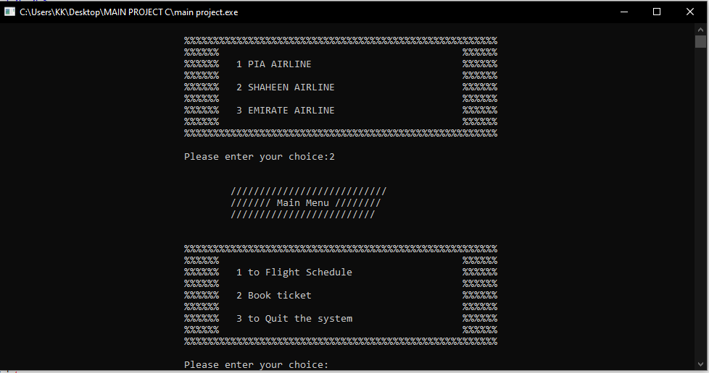

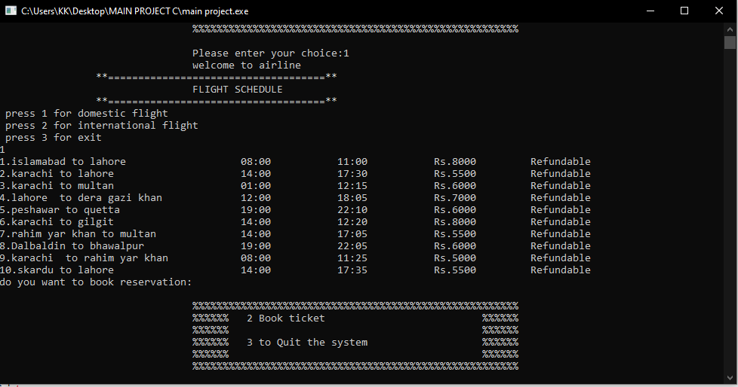

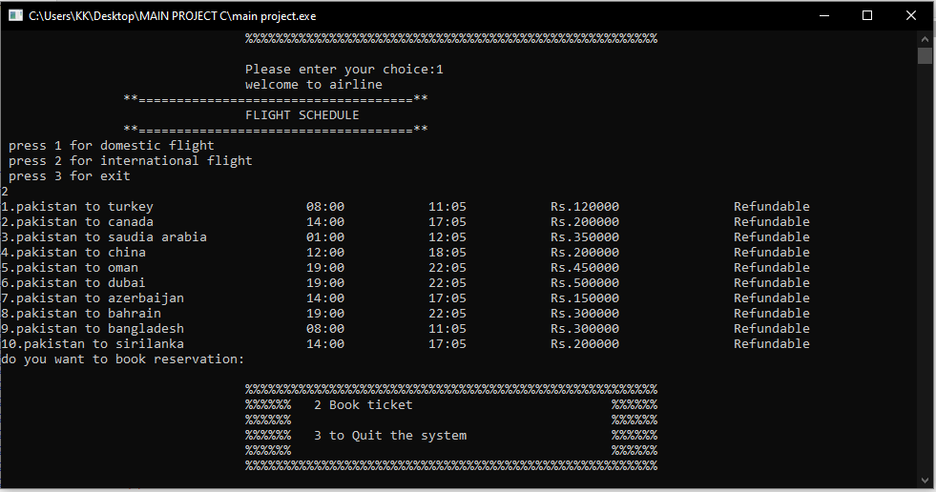

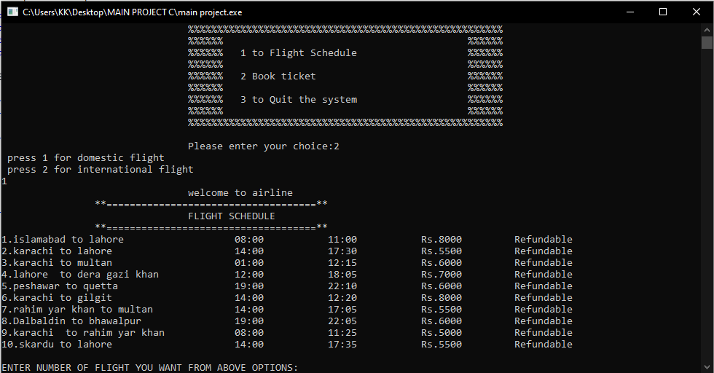

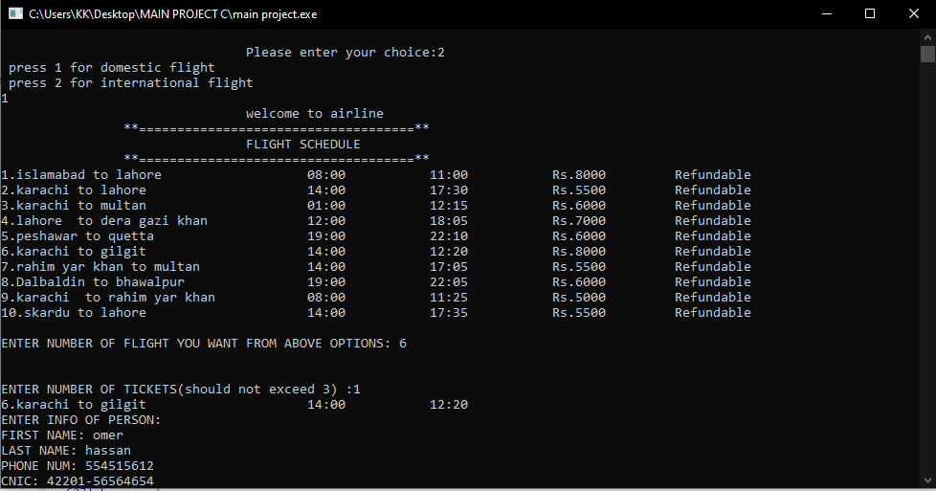

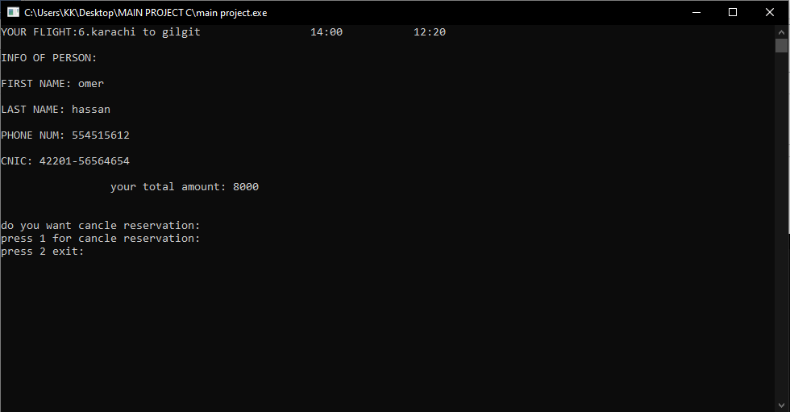

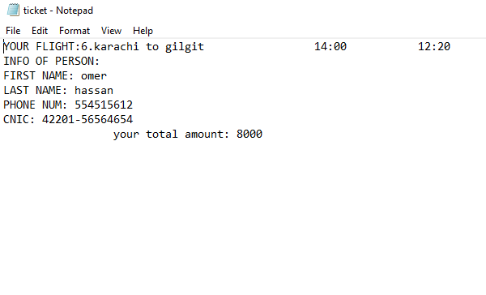

If you want more than one ticket so;

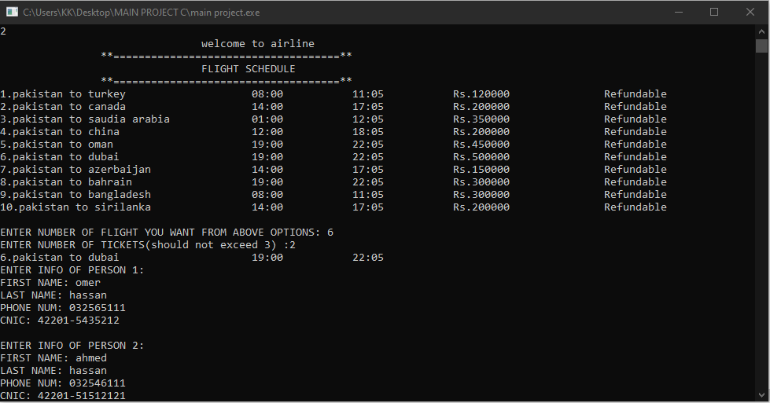

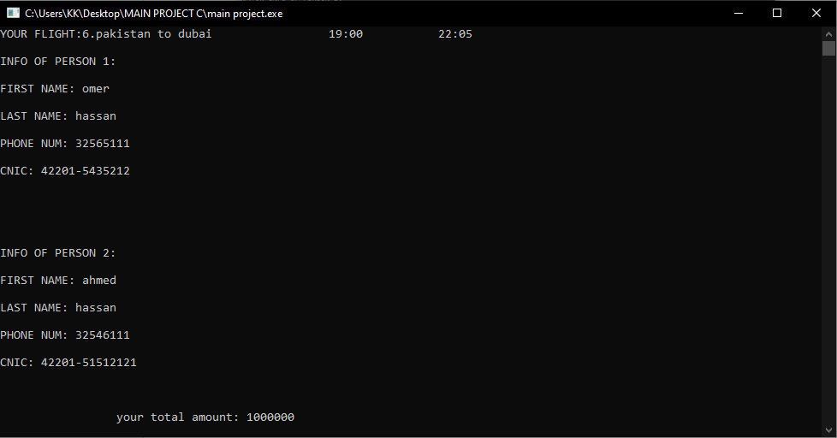

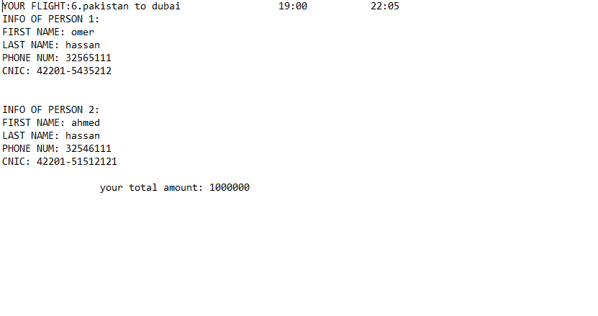

You should not exceed above 3 ticket. Only reserved 3 ticket

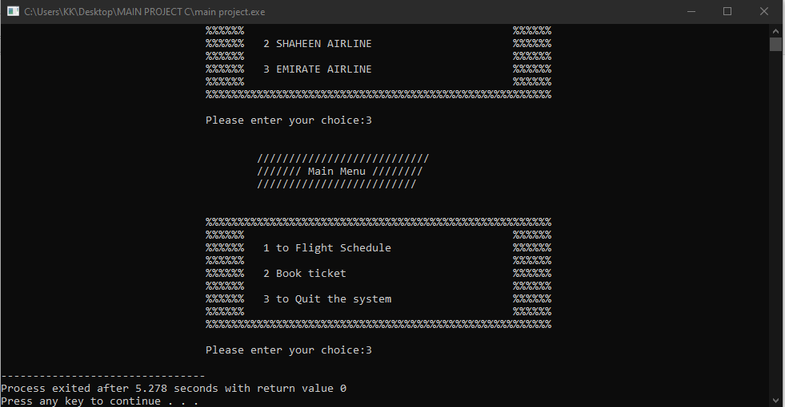

If you do not want any booking or see any scheduling so exit the system